**Azure fundamental assignment 2**

1. What is server less computing?

Server less computing is a feature which enables developers to build application faster by eliminating the need for them to manage infrastructure. The server less name come from the fact that the task associated with infrastructure provisioning and management are invisible to the developer

1. Explain Azure subscriptions, management groups and resources.

Azure **subscription** is a logical container that holds collection of connected resources and used to provision various resources.

**Resource** is a manageable item that is available through Azure. Virtual machines, storage accounts, web apps, databases, and virtual networks are examples of resources. Resource groups, subscriptions, management groups, and tags are also examples of resources.

**Management group** is a feature that allows users to group subscriptions together so that you can apply governance controls such as a policy, Role Based Access Control (RBAC) to multiple subscriptions and their resources with one assignment.

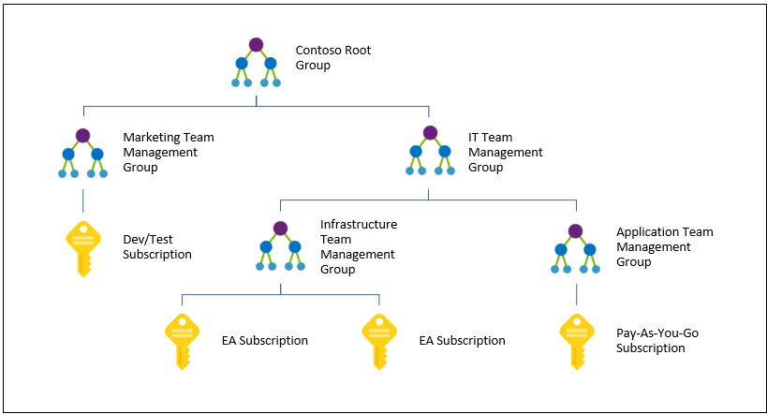

The above diagram shows an example of creating hierarchy for governance using management groups

1. Explain Azure regions, availability zones, and region pairs

Azure **region** features datacenters deployed within a latency-defined perimeter. They're connected through a dedicated regional low-latency network. This design ensures that Azure services within any region offer the best possible performance and security.

Azure ***availability zones*** are physically separate locations within each Azure region that are tolerant to local failures. Failures can range from software and hardware failures to events such as earthquakes, floods, and fires. Tolerance to failures is achieved because of redundancy and logical isolation of Azure services. To ensure resiliency, a minimum of three separate availability zones are present in all availability zone-enabled regions.

Azure availability zones are connected by a high-performance network with a round-trip latency of less than 2ms. They help your data stay synchronized and accessible when things go wrong. Each zone is composed of one or more datacenters equipped with independent power, cooling, and networking infrastructure. Availability zones are designed so that if one zone is affected, regional services, capacity, and high availability are supported by the remaining two zones.

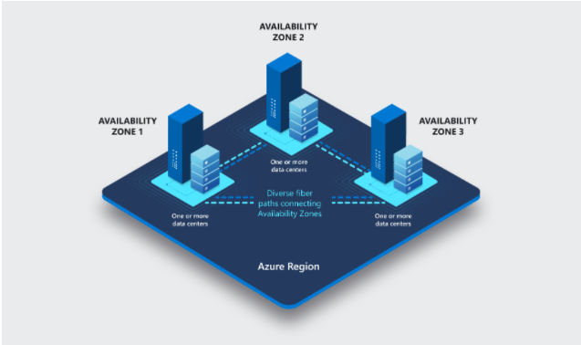

Each region is paired with another region within the same geography (such as Europe, US or Asia) atleast 300 miles away, which together make a **region pair**.

Some services such as Geo redundant storage provide automatic replication to the paired region. In the event of broad outage, recover of one region is prioritized out of every pair. Applications that are deployed across paired regions are guaranteed to have one of the regions recovered with priority.

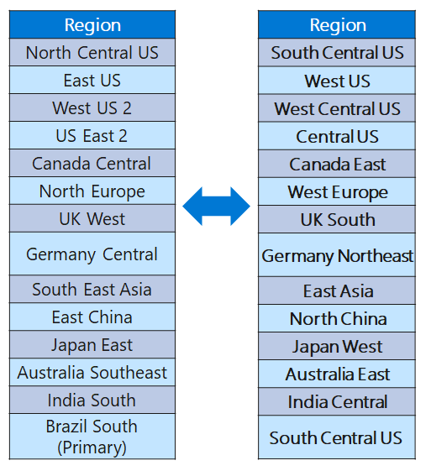

1. Explain Azure Resource Manager, Azure subscription and management group

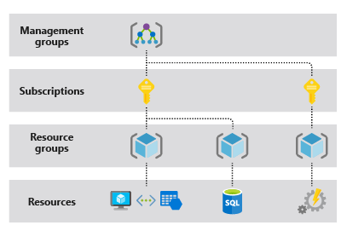

The above diagram explains the relation between Resource, subscription and Management groups.

**Azure Resource Manager** is the deployment and management service for Azure. It provides a management layer that enables you to create, update, and delete resources in your Azure account. You use management features, like access control, locks, and tags, to secure and organize your resources after deployment.

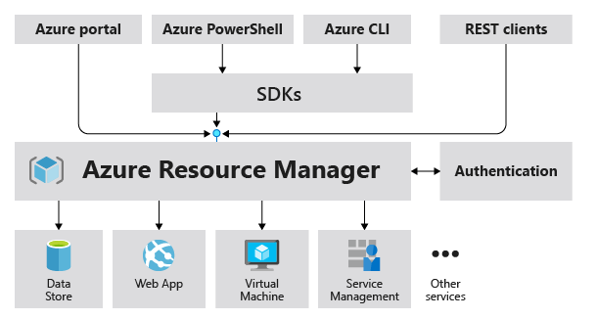

The above diagram shows the role of Azure Resource Manager for handling Azure requests

1. Provide overview of Azure Compute Services

Azure Compute provides an on-demand computing service in order to run cloud-based applications. Computing resources, for instance, processors, memory, storage, operating systems, networking are all provided by the Azure Compute. On-demand resources are available via Azure to compute and thus can be setup in a matter of minutes and for services in just a few seconds. The payment module is pay-as-you-go and only for the time the resources are in use.

Different services under Azure Compute are:

* Azure Virtual Machines
* Azure App Service
* Azure Container Instances
* Azure Kubernetes Service
* Azure Functions
* Azure Virtual Desktop

1. What is an Azure virtual machine and when to opt for an Azure virtual machine?

Azure **Virtual Machines** are image service instances that provide on-demand and scalable computing resources with usage-based pricing.

More broadly, a virtual machine behaves like a server: It is a computer within a computer that provides the user the same experience they would have on the host operating system itself. In general, virtual machines are sandboxed from the rest of the system, meaning that the software inside a virtual machine cannot escape or tamper with the underlying server itself.

Each virtual machine provides its own virtual hardware including CPUs, memory, hard drives, network interfaces and other devices.

**Virtual Machines are recommended** for workloads which do not require any significant amount of computation power, network traffic or disk IO. They are recommended for small servers, low-traffic web servers, or development environments. If you are unsure about which type of VM to use, this is a good place to start. Here is a breakdown of the different series of general purpose VMs:

* Av2 / Dv2 / DSv2 / Dv3 / Dsv3-series VMs are designed as entry-level VMs and offer consistent processor performance with different memory capacity and processors
* B-series VMs are designed for burstable workloads which means that they usually operate at a lower-performance CPU baseline, but have the ability to quickly expand and use additional capacity if needed
* DC-series VMs are optimized to securely protect sensitive data and applications using Intel processors with SGX technology